Eventi
Use Case Diagram

Submitted to:

Prof. Ma. Rowena C. Solamo
Faculty Member
Department of Computer Science
College of Engineering
University of the Philippines, Diliman

Submitted by:
Dimaano, Aaron Diego I.
Lopez, Matthew S.
Torres, Jacob Angelo V.

In partial fulfillment of Academic Requirements
for the course
CS 191 Software Engineering I
of the
1st Semester, AY 2015-2016
Unique Reference:
The documents are stored in this repository: https://github.com/Tom-2013-06417/CS191-192_Event_Sharing.
Link to this document: https://github.com/Tom-2013-06417/CS191-192_Event_Sharing/blob/master/02-Requirements%20Engineering/Eventi%20-%20Use%20Case%20Model.pdf.

Document Purpose:
The purpose of this document is to further conceptualize how the users are to interact with the software by means of a UML User Case Model diagram. Through the diagram, the actors and their specific tasks are specified in terms of a high-level overview.

Target Audience:
To our project client and adviser, our fellow 191 classmates, and our future selves when they need to refer back to this document.

Revision Control:

Revision Date | Person Responsible | Version  Number | Modification
09/18/15 | Diego Dimaano  Matthew Lopez  Jacob Torres | 1.0 | Initial Document.

System Name: Eventi

Description:
Eventi is a website that aims to centralize all general events within the university and therefore providing a platform for those who seek publicity for their event as well as for those who want a single go-to site containing for everything they need to know about the events in UP.

Use-Case Diagram:

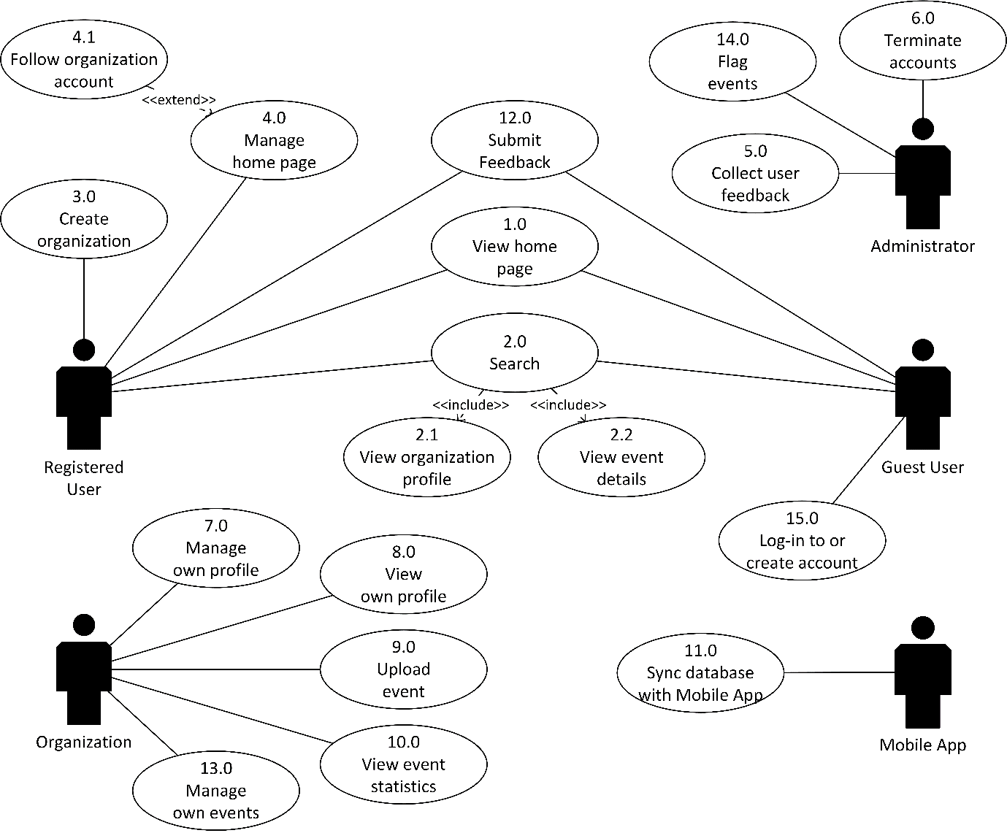

List of Actors:

Actors | Description
Registered User | These actors are users with Eventi accounts. They are the ones responsible for posting and managing events. They also possess heightened features that differ from Guest Users.
Organizations | These entities would serve as the medium for Registered Users to post events under the name of an organization. The Users would post their events through here for the Guest User to see. It is similar to Pages in Facebook.
Guest User | All newcomers of Eventi are classified as Guest Users. These actors are the non-registered, free roaming users of Eventi. Their only purpose is to search and view the posted events. They can upgrade to be a Registered User.
Mobile App | This is the external entity. It would be in sync with the website and the databases in real time. This is basically the link between the two systems. The other way around also applies (App to Website).

List of Use-cases:

Use-Case | Description
Use-Case 1.0  View home page | This is the first page a user sees after loading the Eventi website. Displayed in the home page are the different events ranging in various tiles depending on popularity. Everyone is a Guest User unless they register and log in the site.
Use-Case 2.0  Search | The Eventi system’s main feature is search. The search function would be acted by both Guest and Registered Users. The function would include tags and filters as to limit search queries and display the most relevant answers.
Use-Case 2.1  View Organization profile | This is a fundamental operation of any Eventi user. As the search results are displayed, users have the option of viewing the organization profile handling the event. The user is redirected to the organization’s profile if requested. The organization profile can also be accessed when a Registered User visits his home page inclusive of the list of subscriptions.
Use-Case 2.2  View event details | This is a drop-down feature of the after-search page. The users would see the important details of the event, including tags, and the organization itself. Users may see a small statistic indicating how many people are going to the event.
Use-Case 3.0  Create Organization | This is a feature concerning the Registered User. If an organization page does not exist, a user may create one and use it as the medium to post events under the organization name. This serves as the centralization of events per org.
Use-Case 4.0  Manage home page | This is a feature concerning the Registered User. This allows for customization of what events are to be displayed to their home page based on their subscriptions. Additional customizations include display by relevance or popularity.
Use-Case 4.1  Follow Organization account | This is an added functionality for registered users so that they keep updated regarding the events held by a certain organization. The events held by followed organizations shall appear on the registered user’s events board. Of course, if there’s a feature to follow an organization, there’s also the choice of unfollowing the organization, so that they no longer appear on the registered user’s events board.

Use-Case 5.0  Collect user feedback | If a user submits feedback, there has to be someone ready to collect it so that it may be acted upon. Related to reporting content, this helps improve the site’s environment while improving its other functionalities.
Use-Case 6.0  Terminate accounts | By controlling who stays within the site’s community, administrators can culture a healthy environment. This also provides an avenue for people who have forgotten or need help with their account credentials.
Use-Case 7.0  Manage own profile | Details change from time to time. By allowing people to update their organization’s data, we’re accommodating the idea that their organizations are developing and are continuing to do so. By keeping data up-to-date, viewers are granted access to all the relevant information they need.
Use-Case 8.0  View own profile | See how others see your organization. This functionality allows the organization’s managers to see how they can improve the presentation of their organization to the viewer’s.
Use-Case 9.0  Upload event | A core functionality of the site. This feature allows users to upload their events to the site for all users to see. This action requires the user to be part of an organization, since an event is going to be attributed to an organization.
Use-Case 10.0  View event statistics | A feature which allows you to see how well your events have been doing. This functionality aims to provide you with statistical data which you can use to improve your future events. This is also great for people who need to quantify the objectives for their events.
Use-Case 11.0  Sync database with Mobile App | By synchronizing the web application with the mobile application, Eventi’s reach is widely broadened, providing the app with more coverage. This entails that we have to synchronize our directions, goals, and maybe even interface as well, as to avoid confusion amongst applicants’ nor alumni.
Use-Case 12.0  Submit feedback | This feature catalyzes the improvement of the site. By allowing users to provide feedback, administrators can manage the information coursing through the site. This functionality also allows people to point out points for improvement, which include, but are not limited to, bugs, typos, and grammatical errors within the site.
Use-Case 13.0  Manage own events | This feature lets the organization edit the event once it has been uploaded. Whenever there has been a change in the specifications of the event, the organization has the opportunity to edit the information.
Use-Case 14.0  Flag events | This feature enables control over the site’s content by having the ability to take down events deemed inappropriate by both the administrators and the users.
Use-Case 15.0  Log-in to or create account | This is when a Guest User wants to have an account registered at Eventi, or a Registered User wants to log-int into his account. Creating an account upgrades the status from Guest to Registered, thereby including additional functionalities such as uploading events. Users who are newly registered are no longer called Guest Users.

